Web Dev: Assignment 1 design document

Sa-ood Abrahams
20098990
Creative computing 1st year.

Website about Self
This website will contain information and content relevant to me as a person. It will consist of a basic bio on me, what I’m studying, where I’m from etc. And on the subsequent pages it will have information on my hobbies and interests. Featuring images and videos where applicable. Lastly, I will add a page that goes over goals of mine, this will be the final page of the site.

First Page
The first page will have a header with my name, below it will be a nav bar that links to the other pages. Below that will be the real meat of the page. On the left-hand side will be the basic bio on me and to the right will be a picture of me.
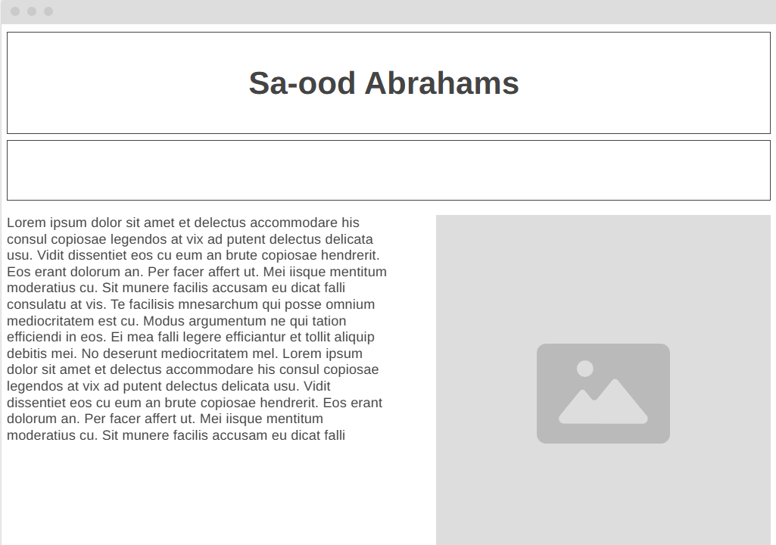

Second page
This page will show off my art and comic projects. Basically being a showcase/portfolio of my work

